**Project Report**

**Title: Digital Level Calibrator Using Arduino Nano**

**Abstract**

This project involves designing and building a digital level calibrator using an Arduino Nano, MPU6050 sensor, OLED screen, and a set of LEDs. The center LED indicates perfect level, the yellow LEDs indicate slight tilt, and the red LEDs indicate extreme tilt. This device can be used in various applications requiring precise leveling.

**Introduction**

In many fields such as construction, carpentry, and DIY projects, maintaining a perfectly level surface is crucial. Traditional spirit levels are commonly used, but they can be limited in precision and readability. This project introduces a digital level calibrator that offers improved accuracy and ease of use.

**Components and Materials**

1. Arduino Nano
2. MPU6050 (accelerometer and gyroscope)
3. OLED Screen (0.96 inch)
4. 5 LEDs (1 Green, 2 Yellow, 2 Red)
5. Resistors (220 ohms)
6. Prototyping board and copper wires
7. Data cable for power supply
8. Buzzer

**Circuit Diagram**

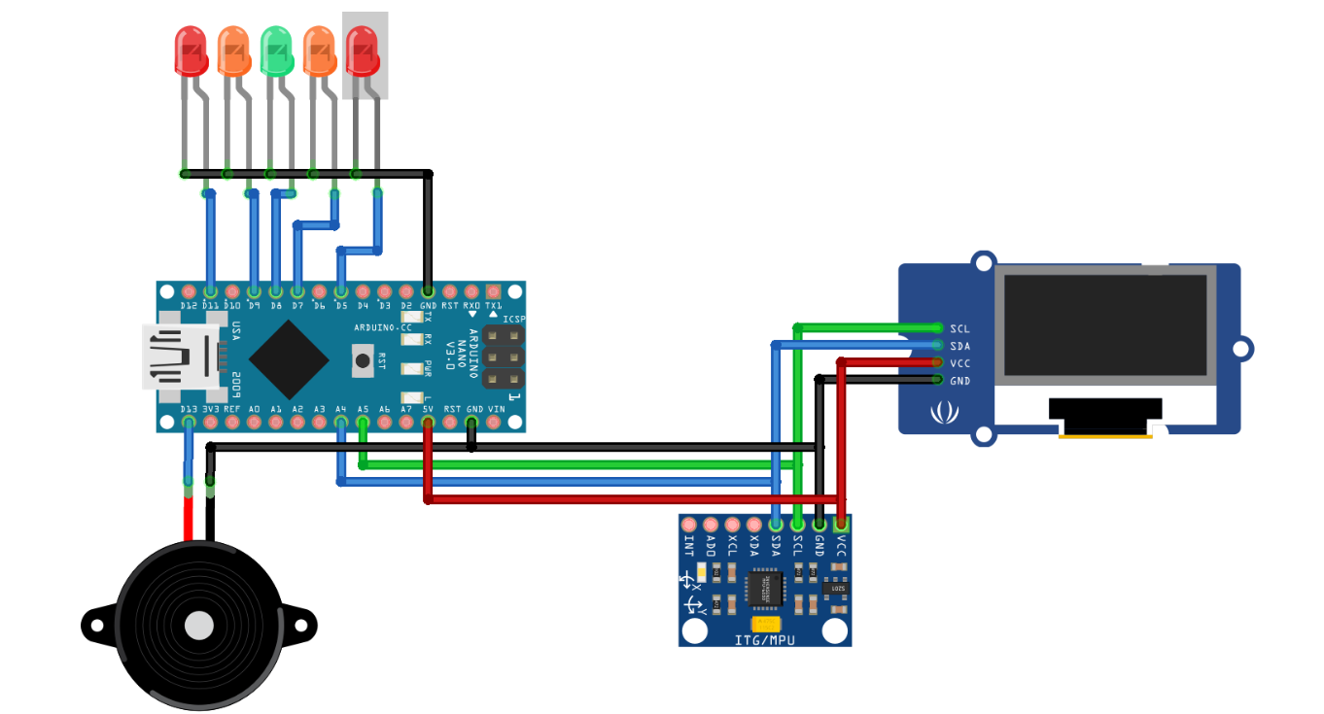

**Working Principle**

The MPU6050 sensor provides acceleration data, which is used to calculate the tilt of the device. The Arduino Nano processes this data and determines the tilt angle. The OLED screen displays the tilt angle in degrees, while the LEDs provide a visual indication of the level status. The center green LED lights up when the device is level, the yellow LEDs indicate a slight tilt, and the red LEDs indicate an extreme tilt.

**Applications**

1. **Construction**: Ensuring that structures and surfaces are level.
2. **Carpentry**: Precise leveling of furniture and installations.
3. **DIY Projects**: Improved accuracy for various home projects.
4. **Industrial Use**: Leveling machinery and equipment.

**Code Explanation**

The code for this project involves initializing the MPU6050 sensor, reading the tilt data, and displaying the tilt status on the OLED screen and LEDs. The LEDs indicate the level status: green for level, yellow for slight tilt, and red for extreme tilt.

**Appendix: Code**

#include <Wire.h>

#include <MPU6050.h>

#include <Adafruit_GFX.h>

#include <Adafruit_SSD1306.h>

// Define LED pins

#define LED_GREEN 2

#define LED_YELLOW1 3

#define LED_YELLOW2 4

#define LED_RED1 5

#define LED_RED2 6

MPU6050 mpu;

Adafruit_SSD1306 display(128, 64, &Wire);

void setup() {

// Initialize LEDs

pinMode(LED_GREEN, OUTPUT);

pinMode(LED_YELLOW1, OUTPUT);

pinMode(LED_YELLOW2, OUTPUT);

pinMode(LED_RED1, OUTPUT);

pinMode(LED_RED2, OUTPUT);

// Initialize MPU6050

Wire.begin();

mpu.initialize();

// Initialize OLED display

display.begin(SSD1306_SWITCHCAPVCC, 0x3C);

display.clearDisplay();

display.setTextSize(1);

display.setTextColor(WHITE);

display.setCursor(0, 0);

display.print("Level Calibrator");

display.display();

}

void loop() {

int16_t ax, ay, az;

mpu.getAcceleration(&ax, &ay, &az);

float ax_g = ax / 16384.0;

float ay_g = ay / 16384.0;

// Calculate tilt

float tilt = atan2(ay_g, ax_g) * 180 / PI;

// Display tilt on OLED

display.clearDisplay();

display.setCursor(0, 0);

display.print("Tilt: ");

display.print(tilt);

display.print(" deg");

display.display();

// Control LEDs based on tilt

if (tilt > -5 && tilt < 5) {

digitalWrite(LED_GREEN, HIGH);

digitalWrite(LED_YELLOW1, LOW);

digitalWrite(LED_YELLOW2, LOW);

digitalWrite(LED_RED1, LOW);

digitalWrite(LED_RED2, LOW);

} else if ((tilt >= 5 && tilt < 15) || (tilt <= -5 && tilt > -15)) {

digitalWrite(LED_GREEN, LOW);

digitalWrite(LED_YELLOW1, HIGH);

digitalWrite(LED_YELLOW2, HIGH);

digitalWrite(LED_RED1, LOW);

digitalWrite(LED_RED2, LOW);

} else {

digitalWrite(LED_GREEN, LOW);

digitalWrite(LED_YELLOW1, LOW);

digitalWrite(LED_YELLOW2, LOW);

digitalWrite(LED_RED1, HIGH);

digitalWrite(LED_RED2, HIGH);

}

delay(500);

}

**Conclusion**

This digital level calibrator provides an accurate and user-friendly way to measure the levelness of surfaces. Its combination of visual LED indicators and a digital readout makes it superior to traditional spirit levels. This project demonstrates the effective use of sensors and microcontrollers to enhance everyday tools.